**Name: Sarthak Shandilya**

**Case study 6 (Ecommerce)**

**Submitted to: Karthika**

**Hexaware Technologies**

**Schema Design:**

**Create database Ecommerce.**

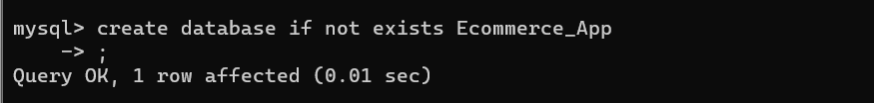

1. customers table:

• customer_id (Primary Key)

• name

• email

• password

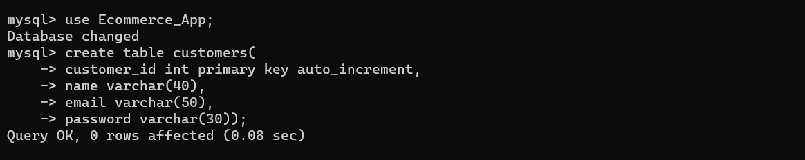

1. products table:

• product_id (Primary Key)

• name

• price

• description

• stockQuantity

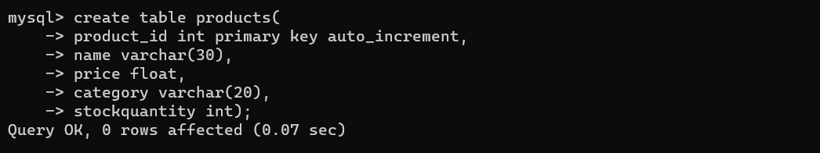

1. cart table:

• cart_id (Primary Key)

• customer_id (Foreign Key)

• product_id (Foreign Key)

• quantity

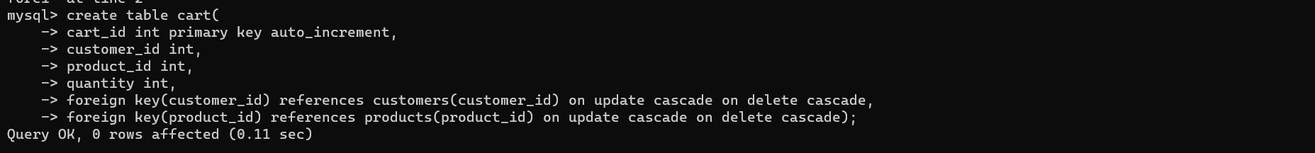

1. orders table:

• order_id (Primary Key)

• customer_id (Foreign Key)

• order_date

• total_price

• shipping_address

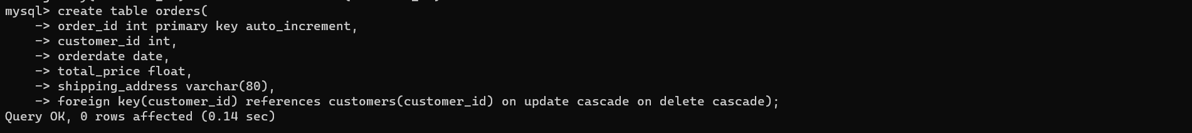

1. order_items table (to store order details):

• order_item_id (Primary Key)

• order_id (Foreign Key)

• product_id (Foreign Key)

• quantity

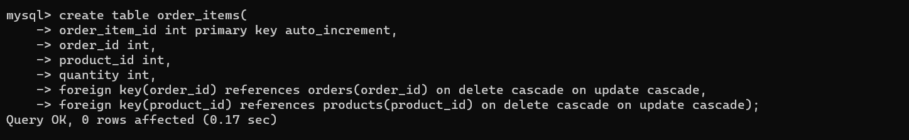

**Classes:**

**Customer:**

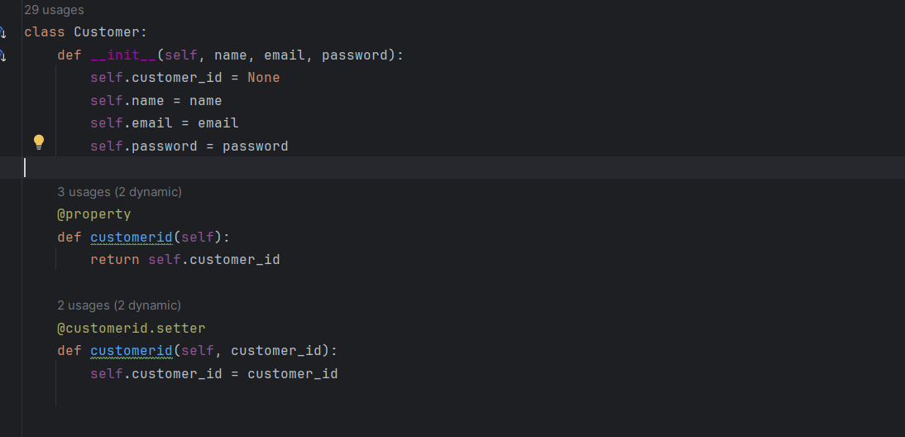

**Products:**

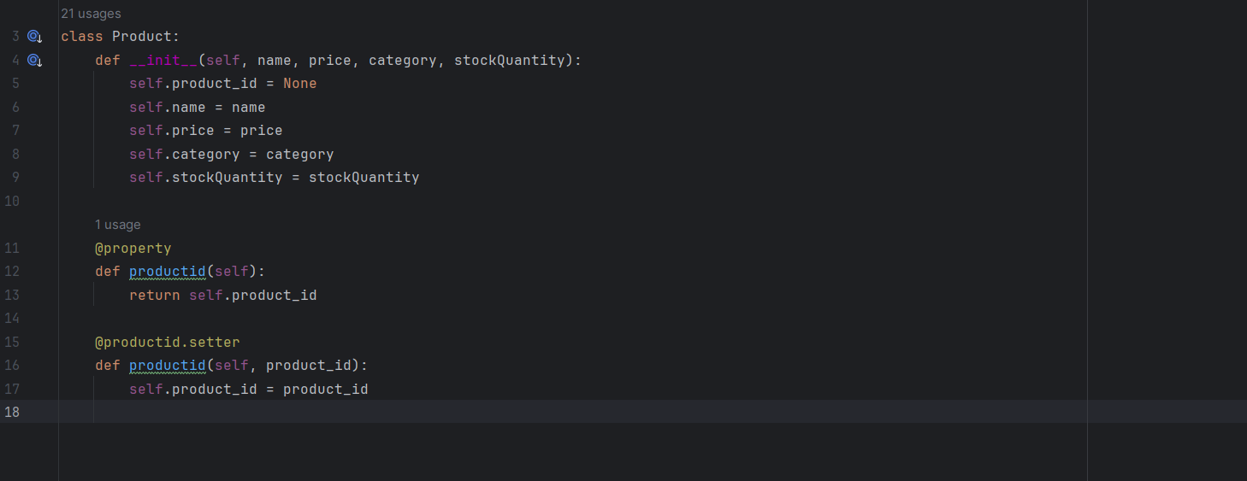

**Orders:**

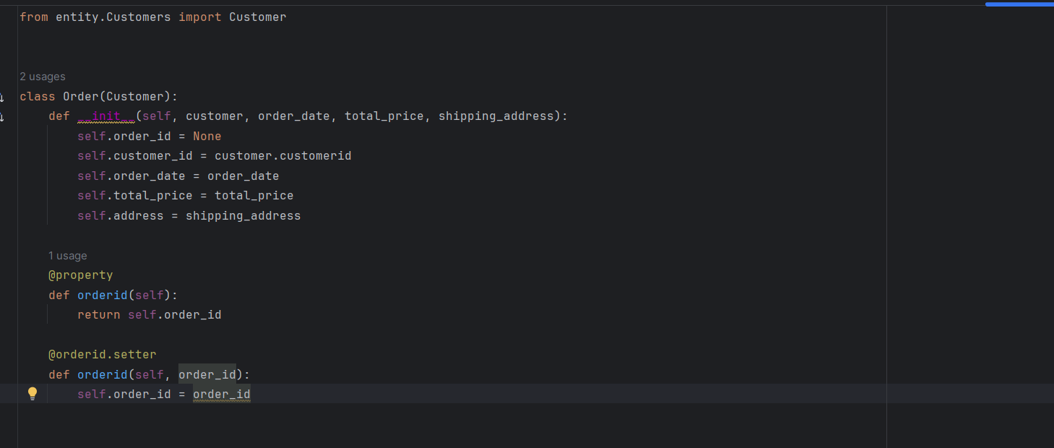

**OrderItems:**

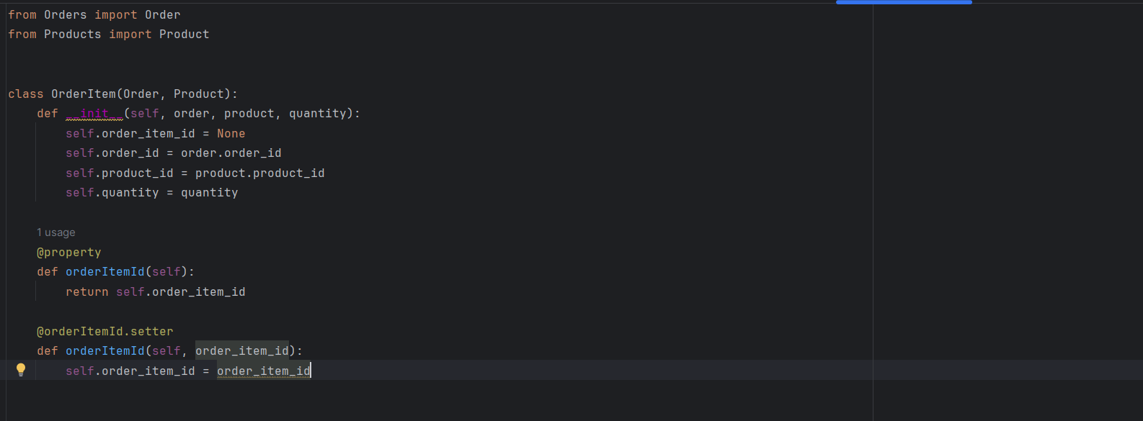

**Cart:**

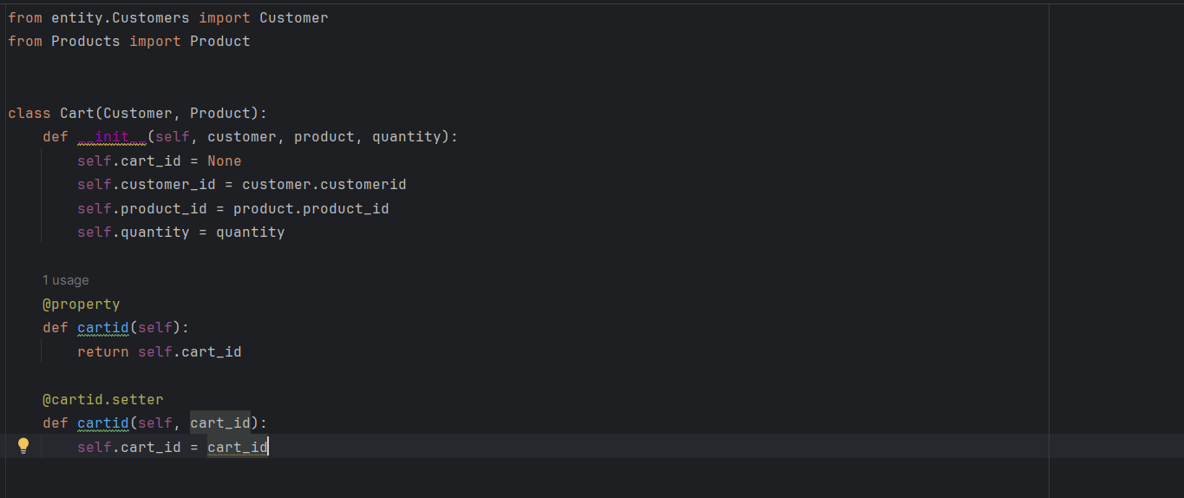

**Service Provider Interface/Abstract class:**

**Keep the interfaces and implementation classes in package dao**

• Define an OrderProcessorRepository interface/abstract class with methods for adding/removing products to/from the cart and placing orders.

The following methods will interact with database.

1. createProduct()

parameter: Product product return type: boolean

2. createCustomer()

parameter: Customer customer

return type: boolean

3. deleteProduct() parameter: productId return type: boolean

4. deleteCustomer(customerId) parameter: customerId return type: boolean

5. addToCart(): insert the product in cart. parameter: Customer customer, Product product, int quantity

return type: boolean

6. removeFromCart(): delete the product in cart. parameter: Customer customer, Product product

return type: boolean

7. getAllFromCart(Customer customer): list the product in cart for a customer.

parameter: Customer customer

return type: list of product

8. placeOrder(Customer customer, List<Map>, string shippingAddress): should update order table and orderItems table.

parameter: Customer customer, list of product and quantity

return type: boolean

9. getOrdersByCustomer()

parameter: customerid

return type: list of product and quantity

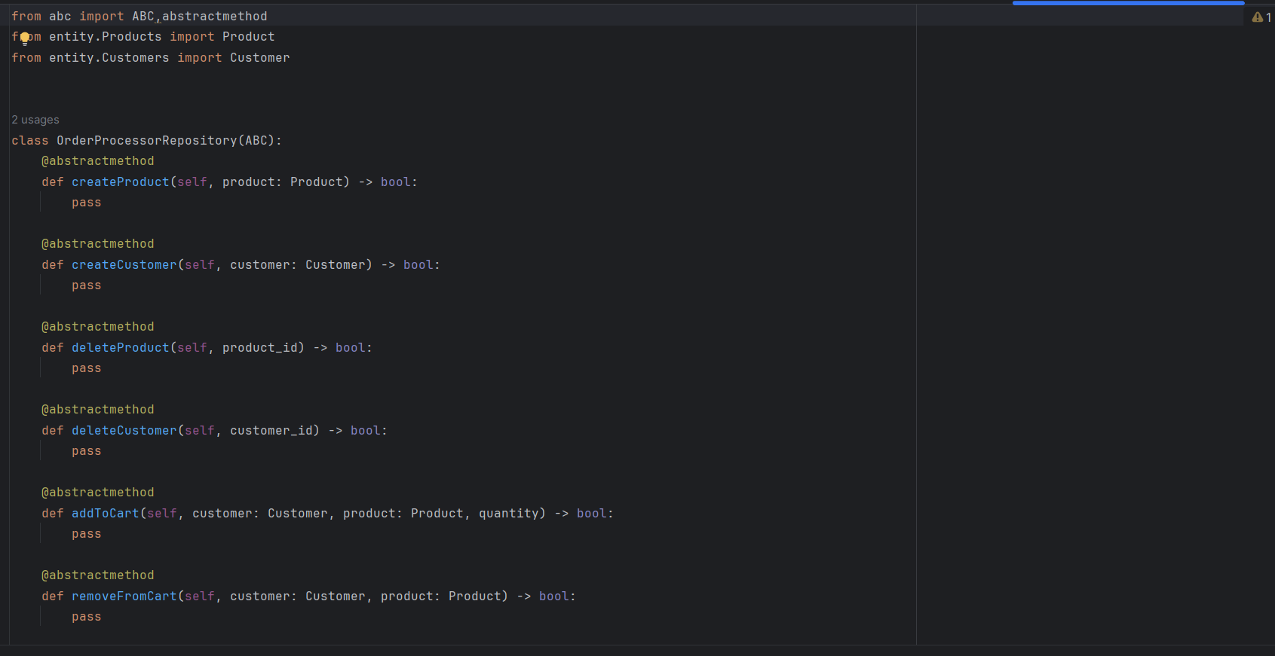

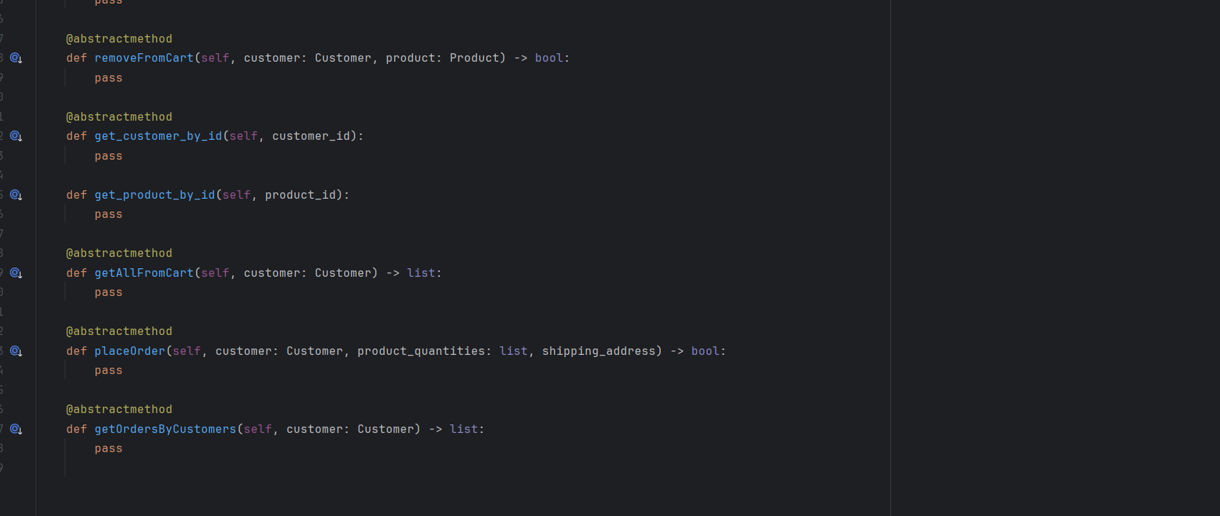

**Implement the above interface in a class called OrderProcessorRepositoryImpl in package dao.**

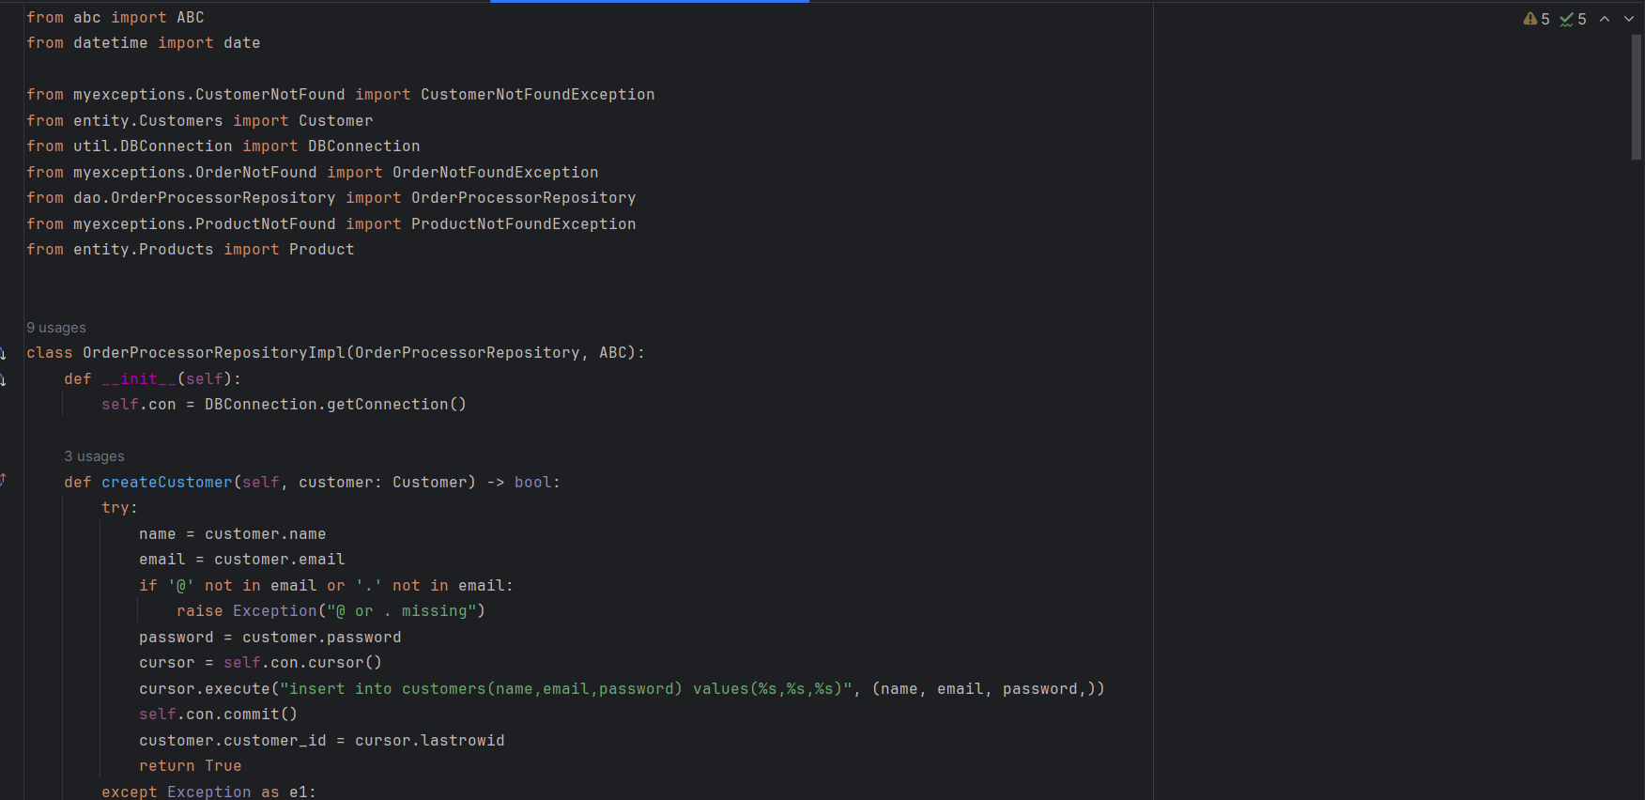

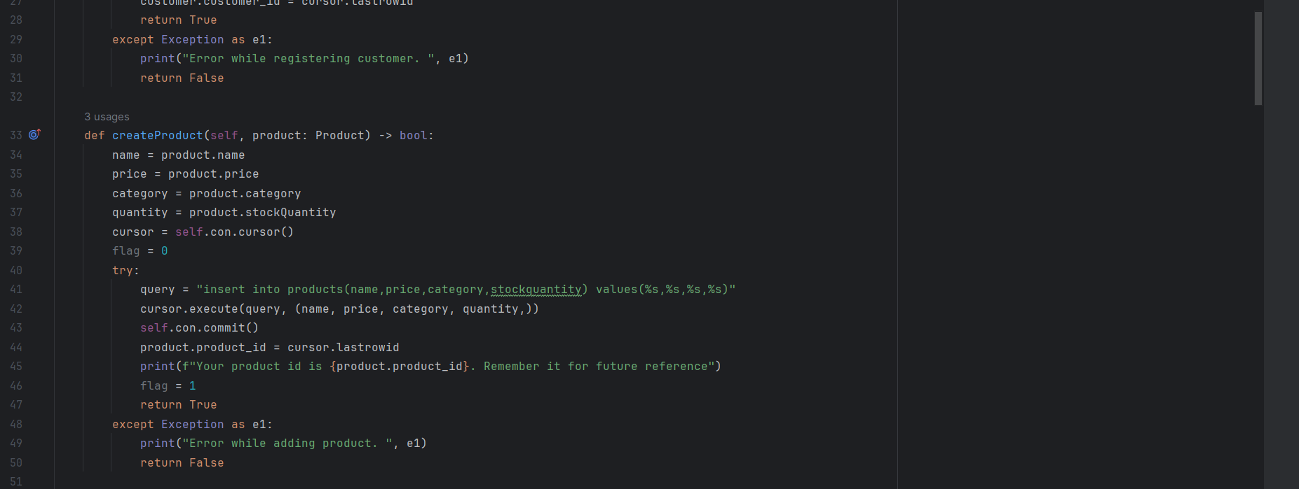

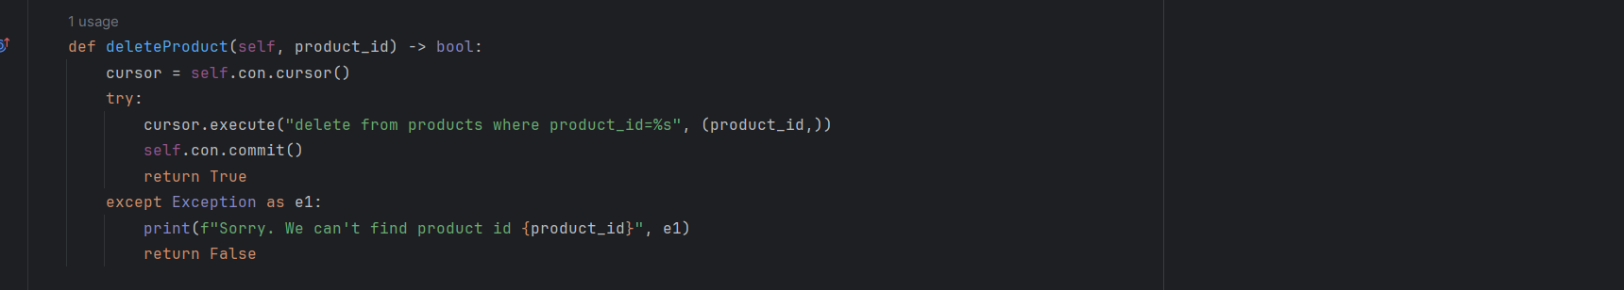

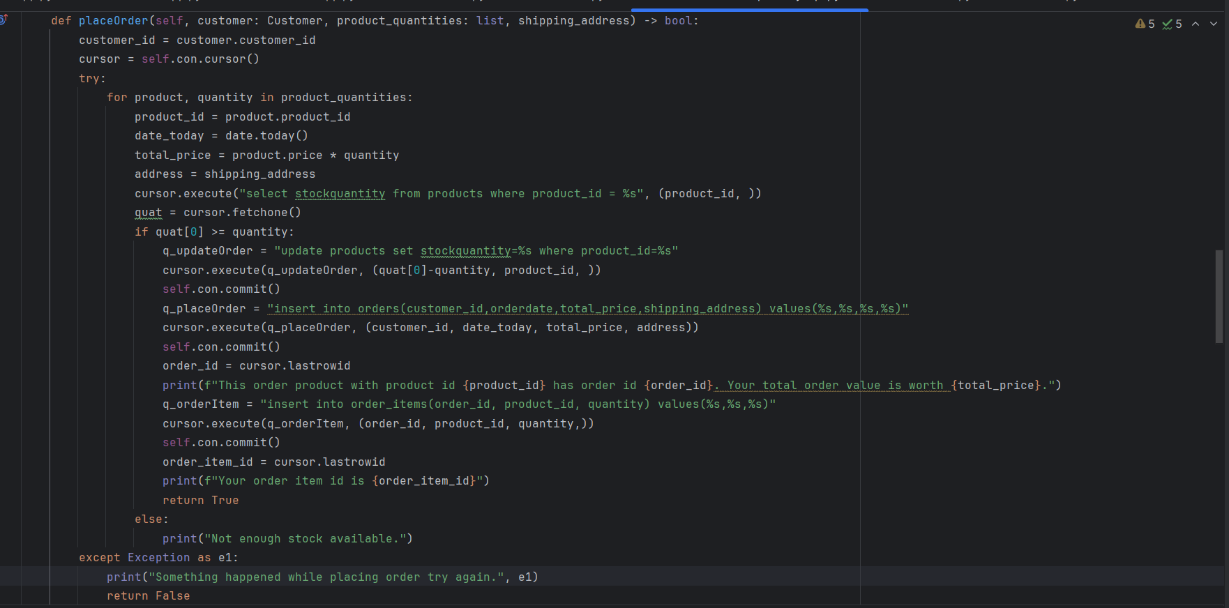

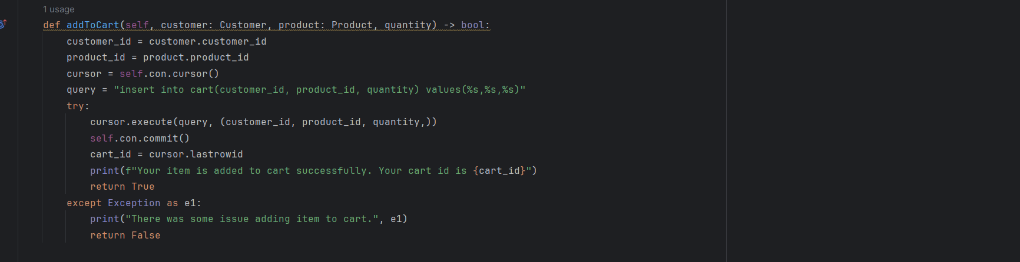

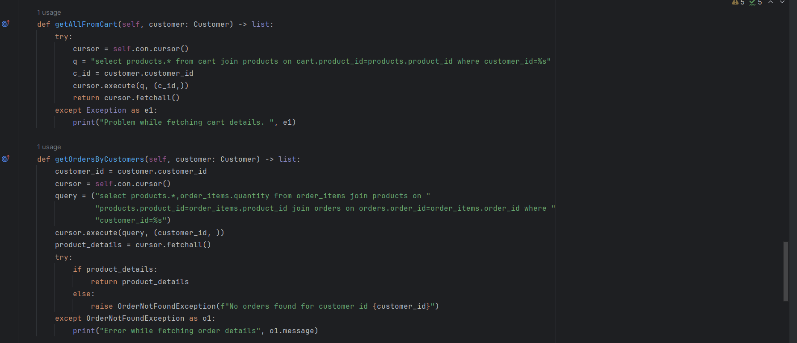

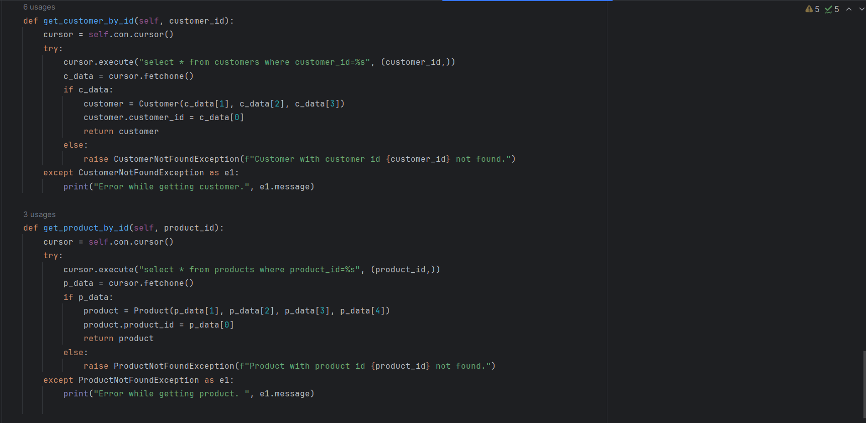

**These are the implementations of every abstract methods.**

**Write code to establish a connection to your SQL database.**

• Create a utility class DBConnection in a package util with a static variable connection of Type Connection and a static method getConnection() which returns connection.

• Connection properties supplied in the connection string should be read from a property file.

• Create a utility class PropertyUtil which contains a static method named getPropertyString() which reads a property file containing connection details like hostname, dbname, username, password, port number and returns a connection string.

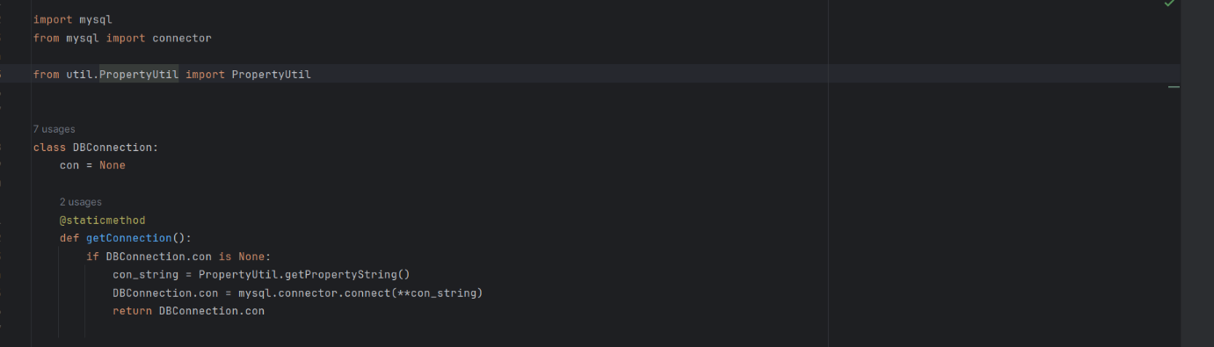

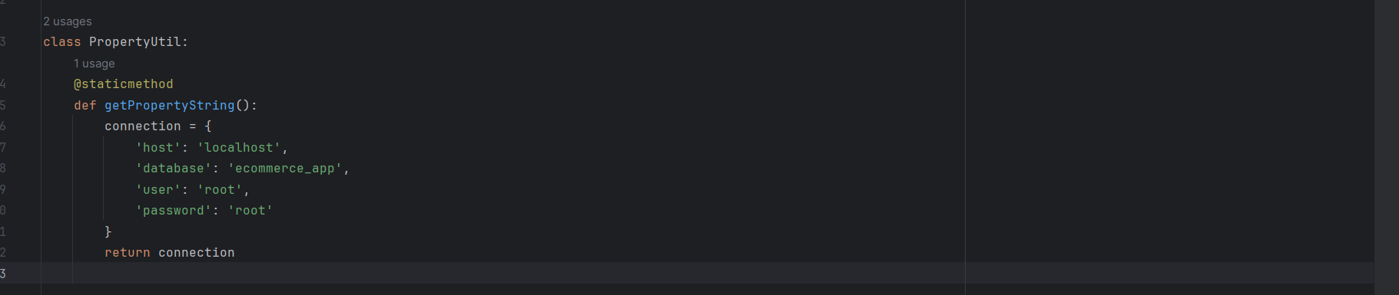

Create the exceptions in package myexceptions and create the following custom exceptions and throw them in methods whenever needed. Handle all the exceptions in main method

• CustomerNotFoundException: throw this exception when user enters an invalid customer id which doesn’t exist in db



• ProductNotFoundException: throw this exception when user enters an invalid product id which doesn’t exist in db

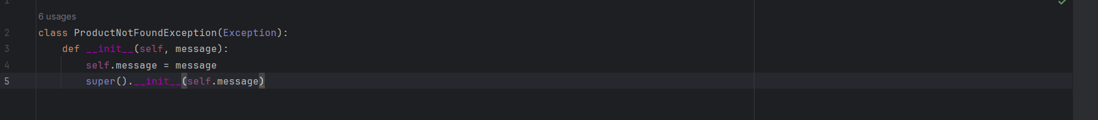

• OrderNotFoundException: throw this exception when user enters an invalid order id which doesn’t exist in db



**Create class named EcomApp with main method in app Trigger all the methods in service implementation class by user choose operation from the following menu.**

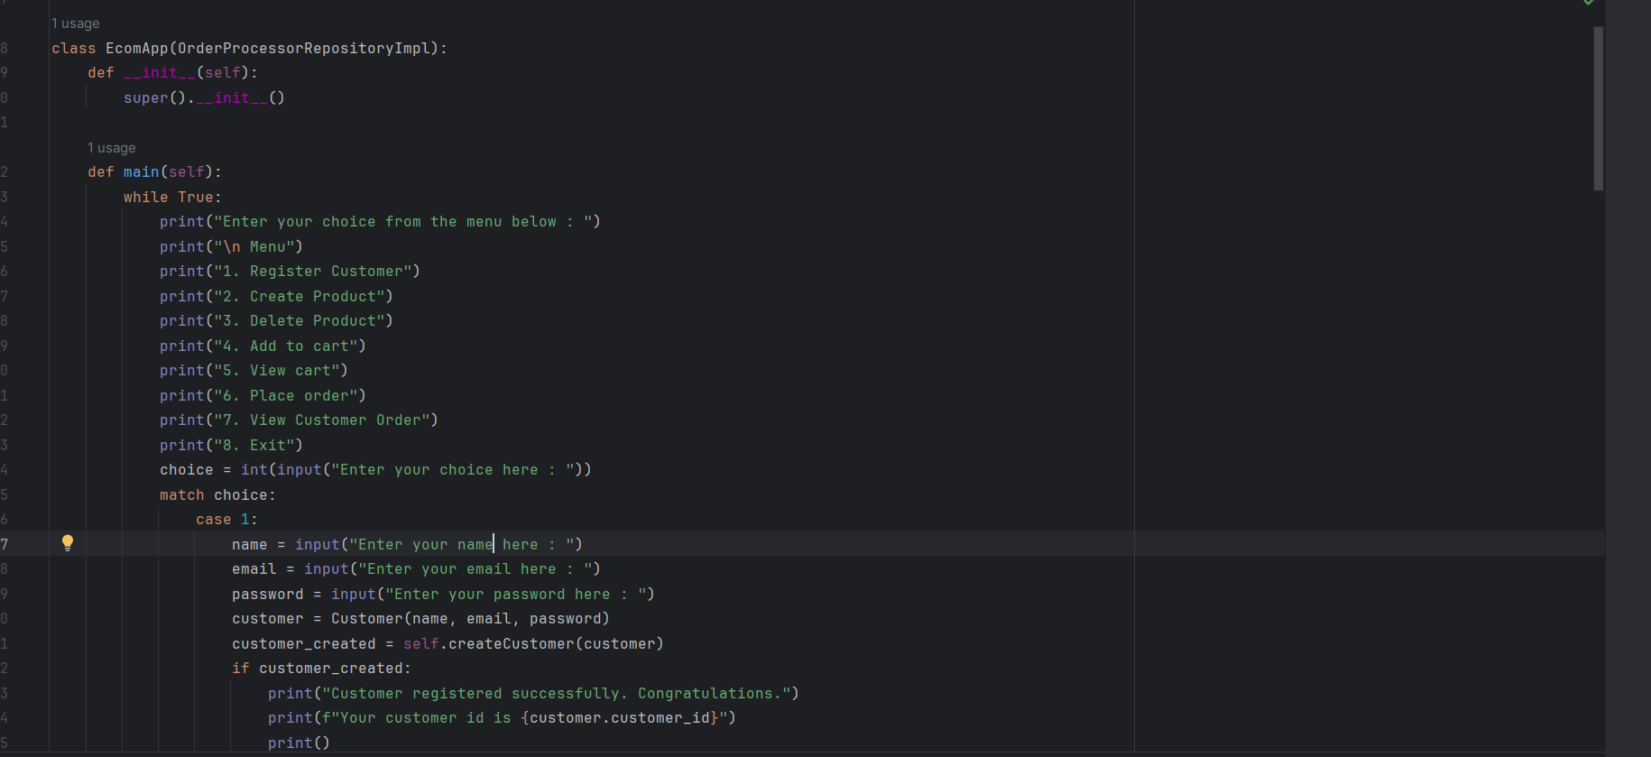

1. **Register Customer.**

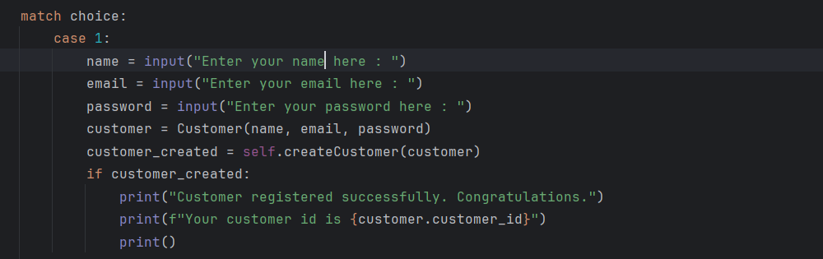

**Output:**

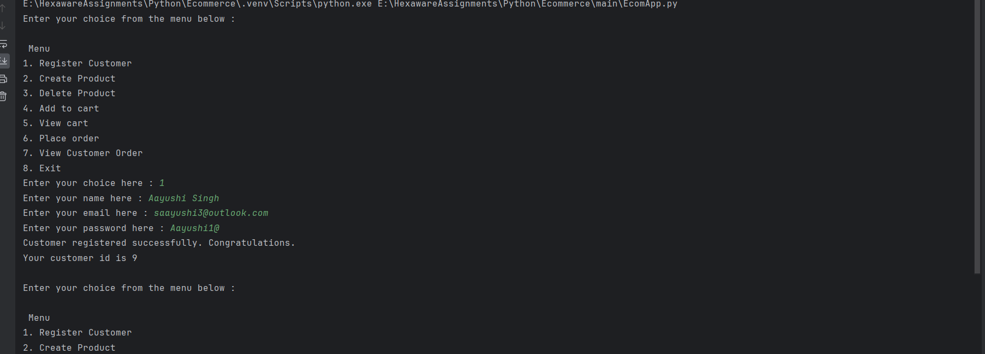

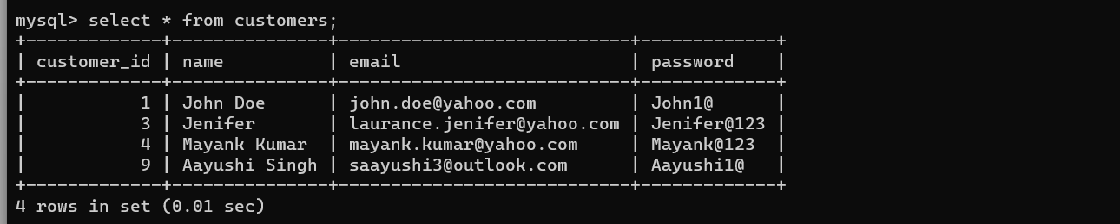

1. **Create Product.**

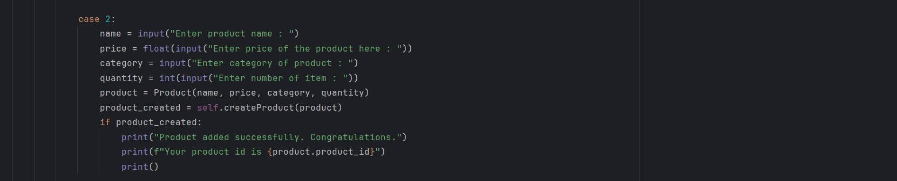

**Output:**

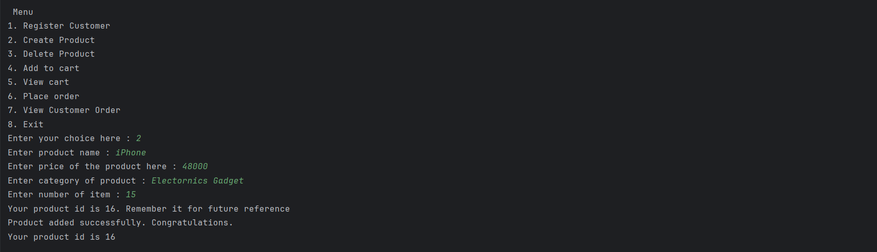

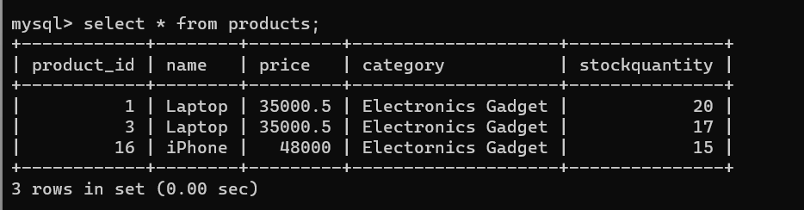

1. **Delete Product.**

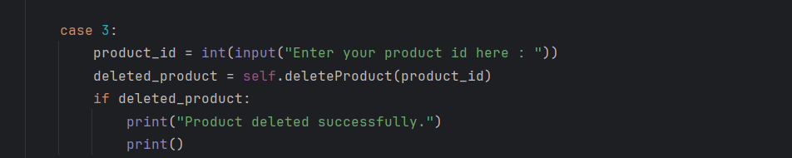

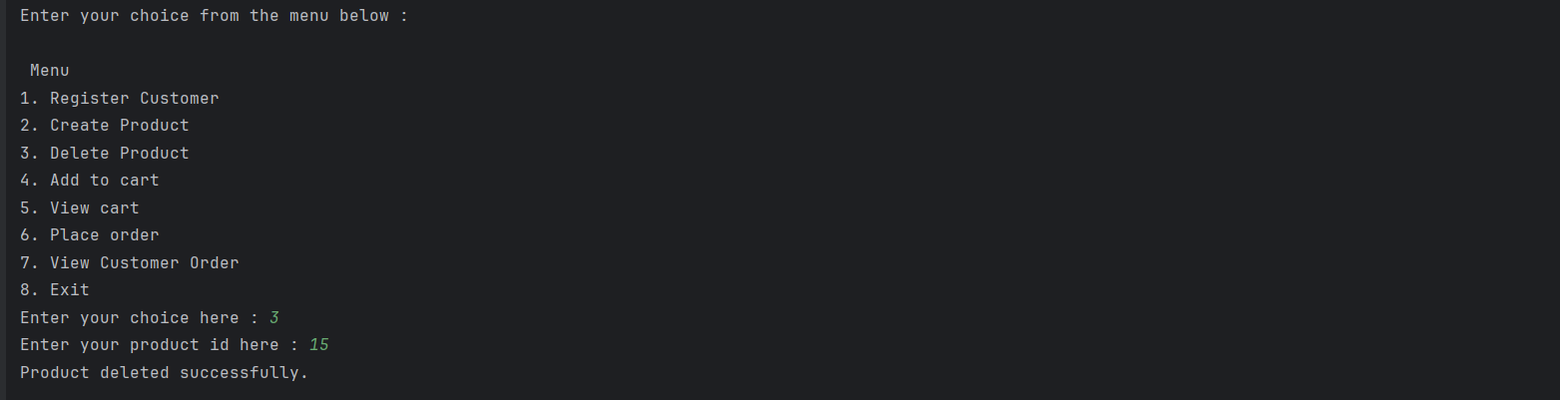

**Output:**



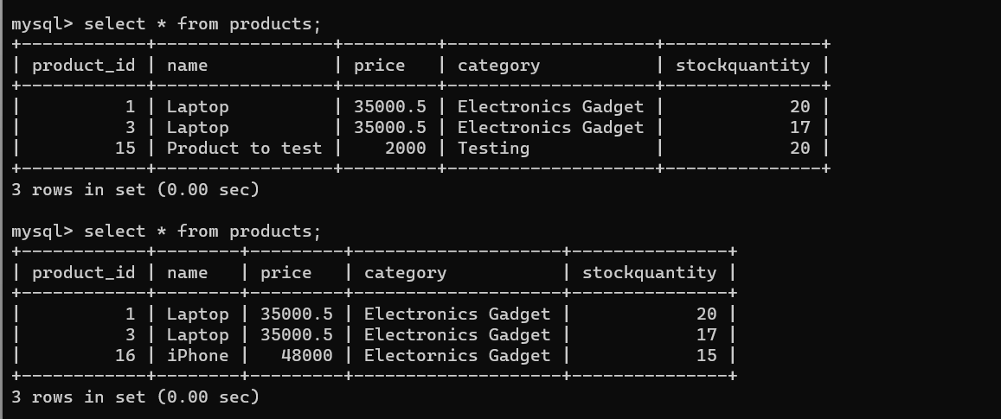

1. **Add to cart.**

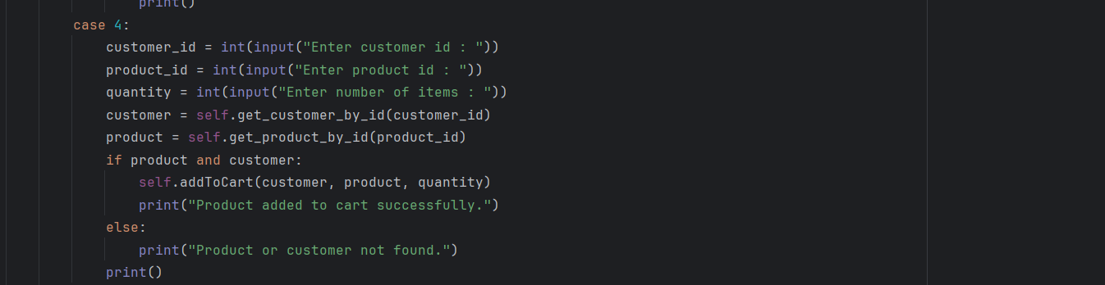

**Output :**

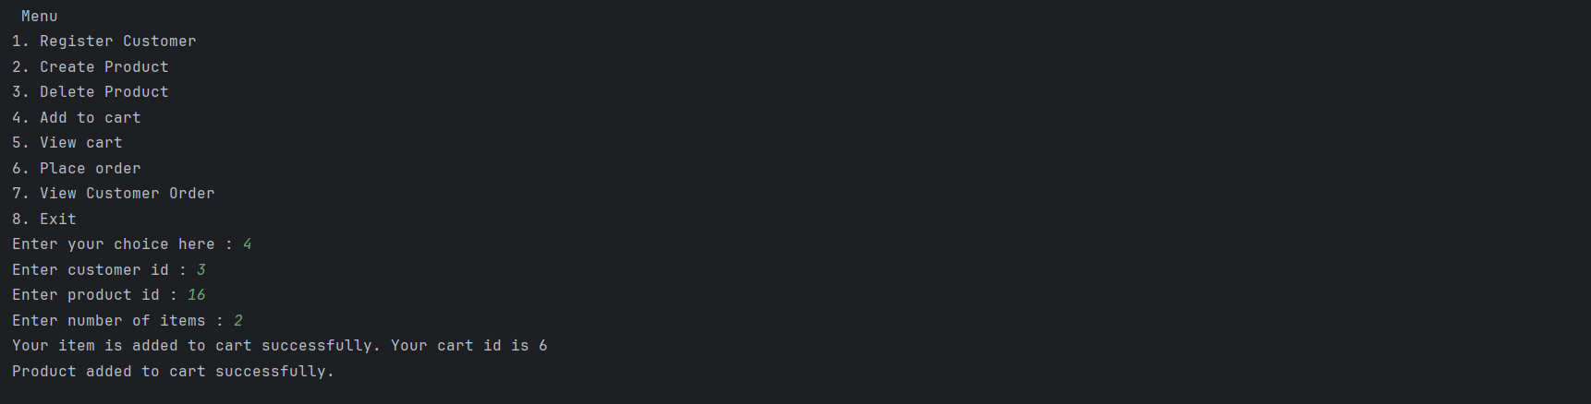

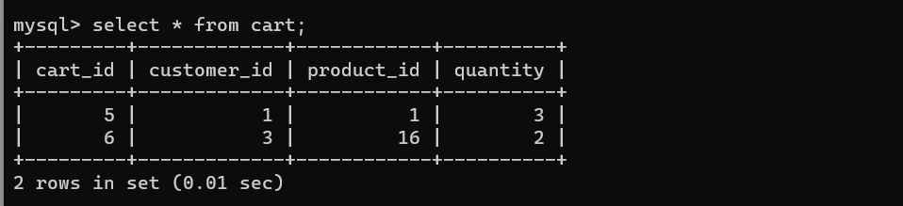

1. **View cart.**

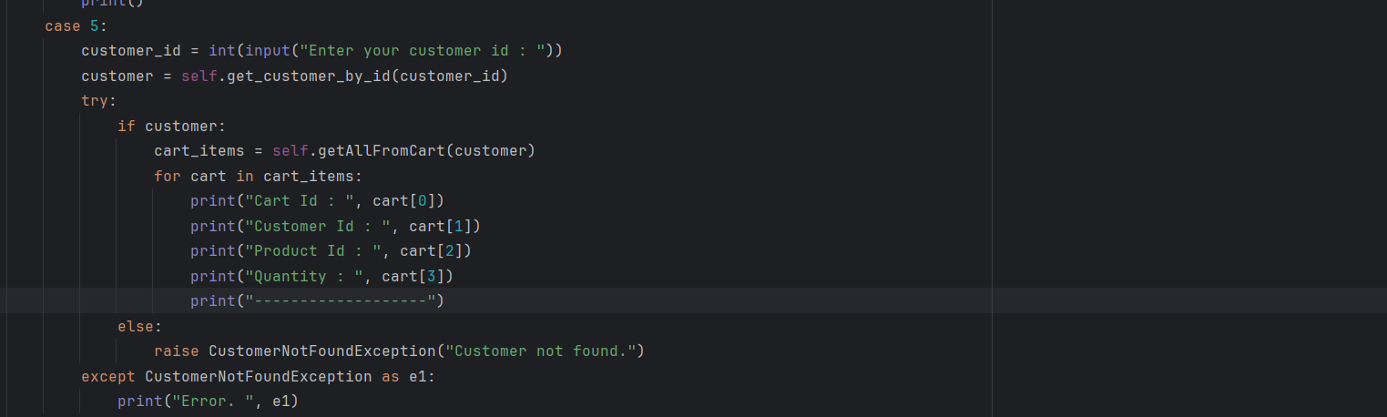

**Output :**

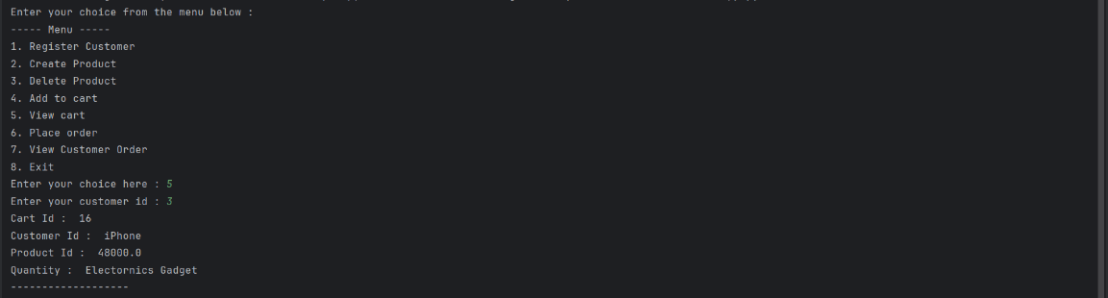

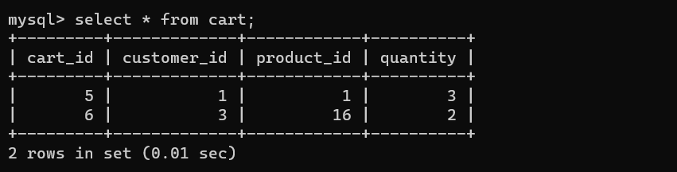

1. **Place order.**

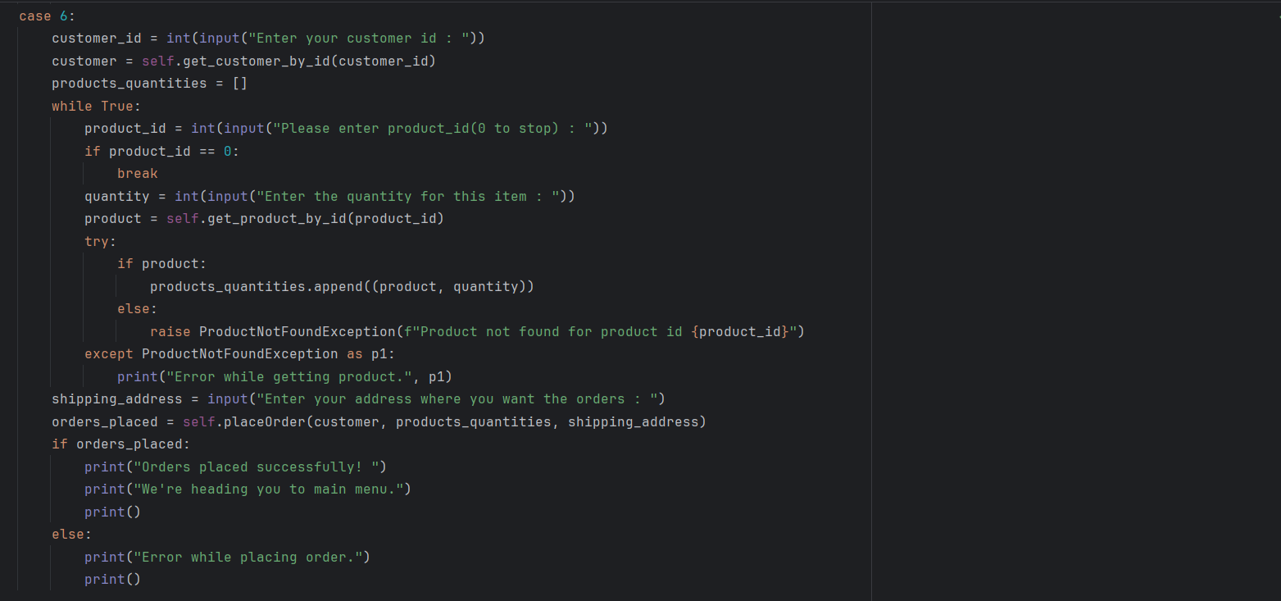

**Output:**

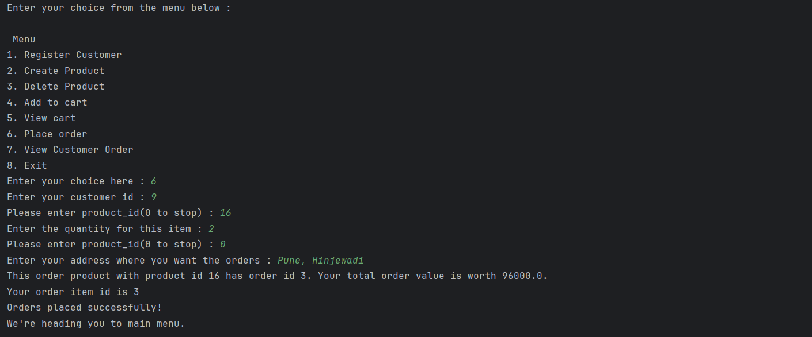

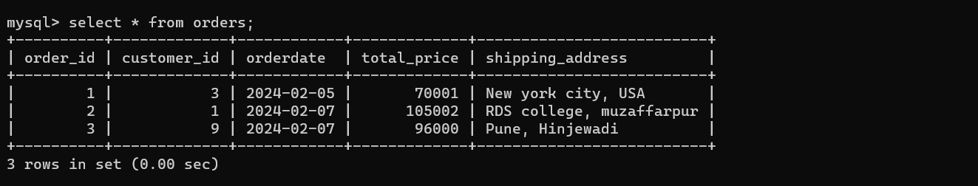

1. **View Customer Order**

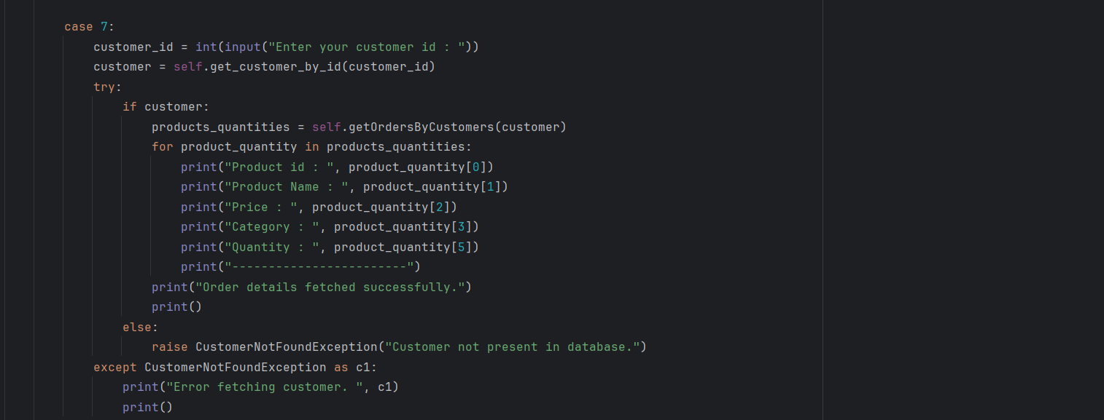

**Output :**

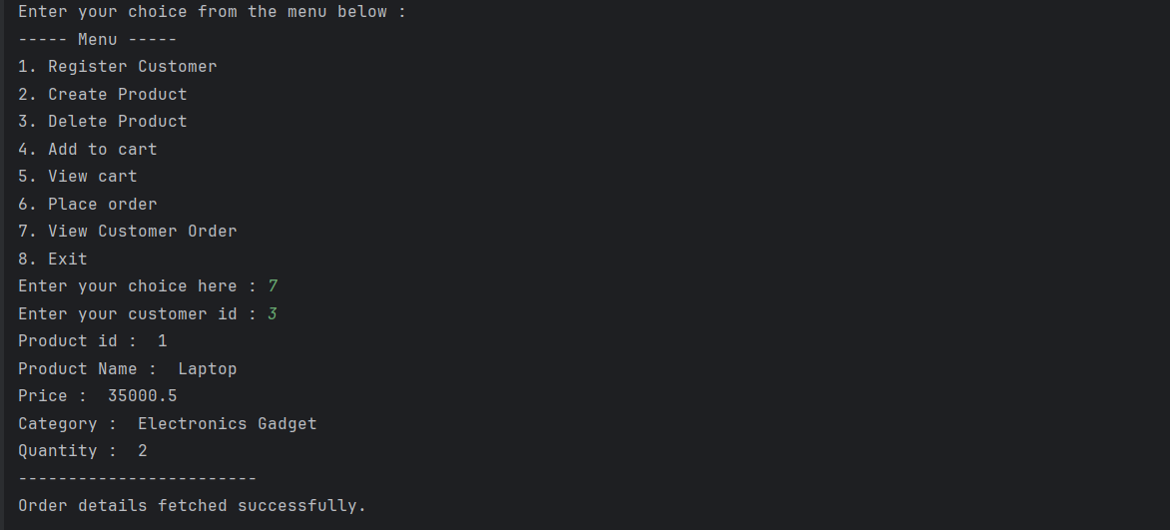

1. **Exit**

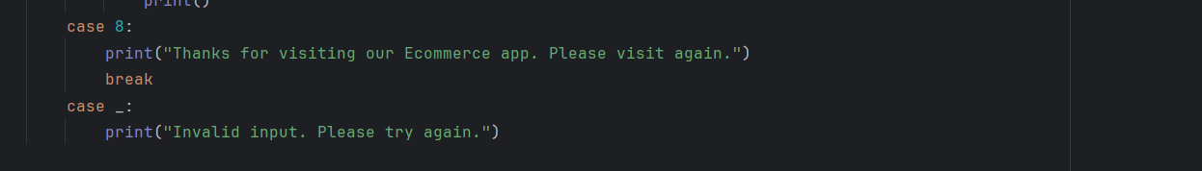

Unit Testing

Create Unit test cases for Ecommerce System are essential to ensure the correctness and reliability of your system. Following questions to guide the creation of Unit test cases:

• Write test case to test Product created successfully or not.

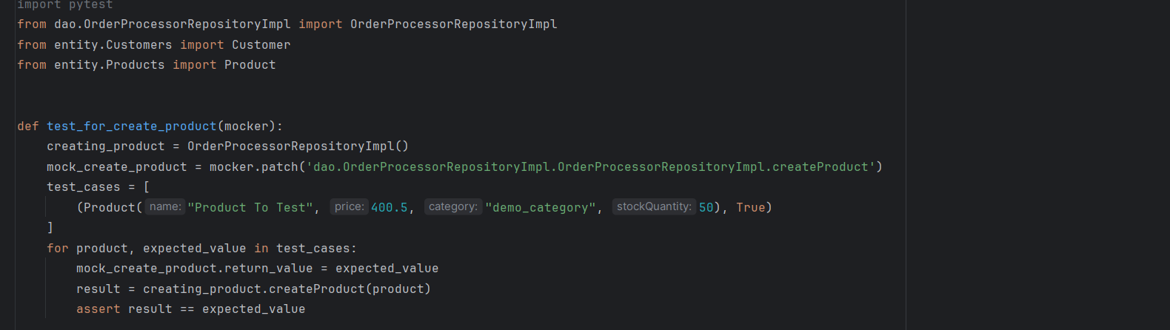

• Write test case to test product is added to cart successfully or not.

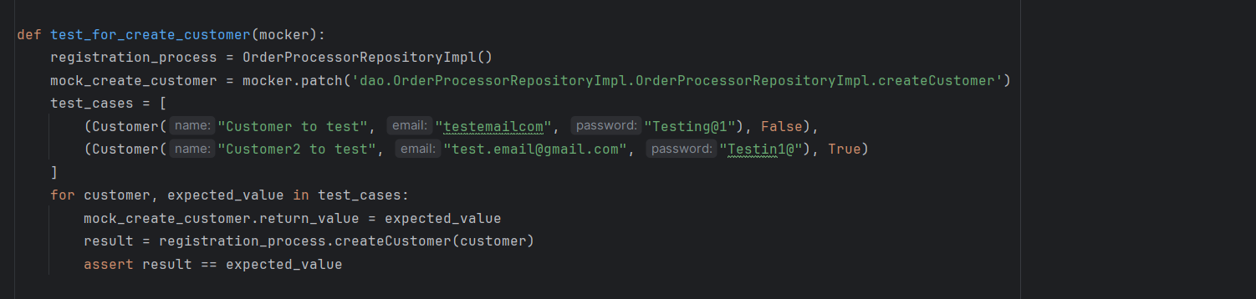

• Write test case to test product is ordered successfully or not.

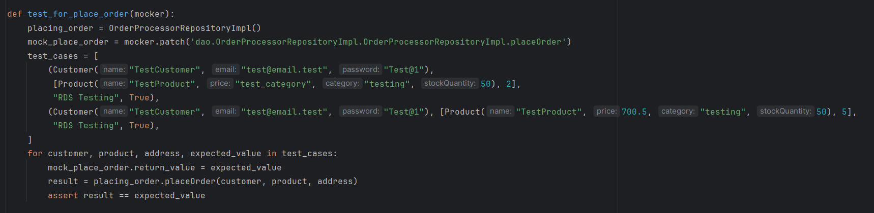

• Write test case to test exception is thrown correctly or not when customer id or product id not found in database.

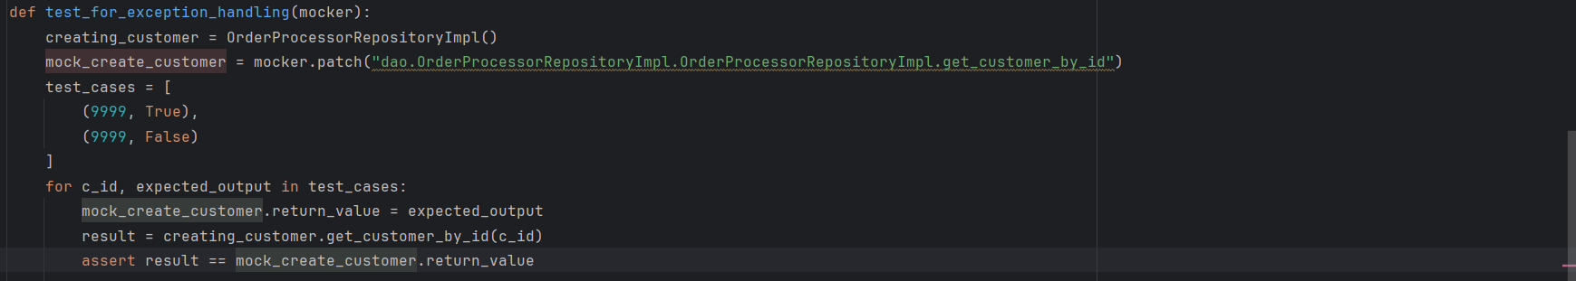

**Output:**

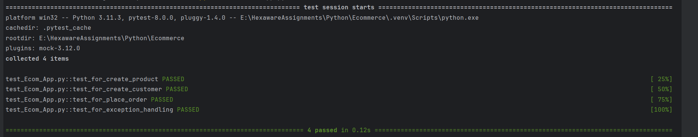

**Package Management:**

